**  
  
Title**:

Analysis and Critique of Visualizations Using OECD Health Statistics

**Prepared by**:  
See Zhi Qian  
**Student ID:**105277702/J22037941

**Course**:  
COS30045 Data Visualisation

**Instructor**:  
Mohamad Faizal Alias

**Date**:  
20th September 2024

**Overview**:  
Based on data from the OECD Health Statistics, three visualizations are analysed and critiqued in this paper. The context, data components, and adherence to important guidelines for efficient data visualization are evaluated in relation to the visualizations. This review aims to evaluate the visualizations' correctness, lucidity, and perceptiveness, offering recommendations for enhancement where necessary.

**Insufficient primary care can contribute to hospital admissions**

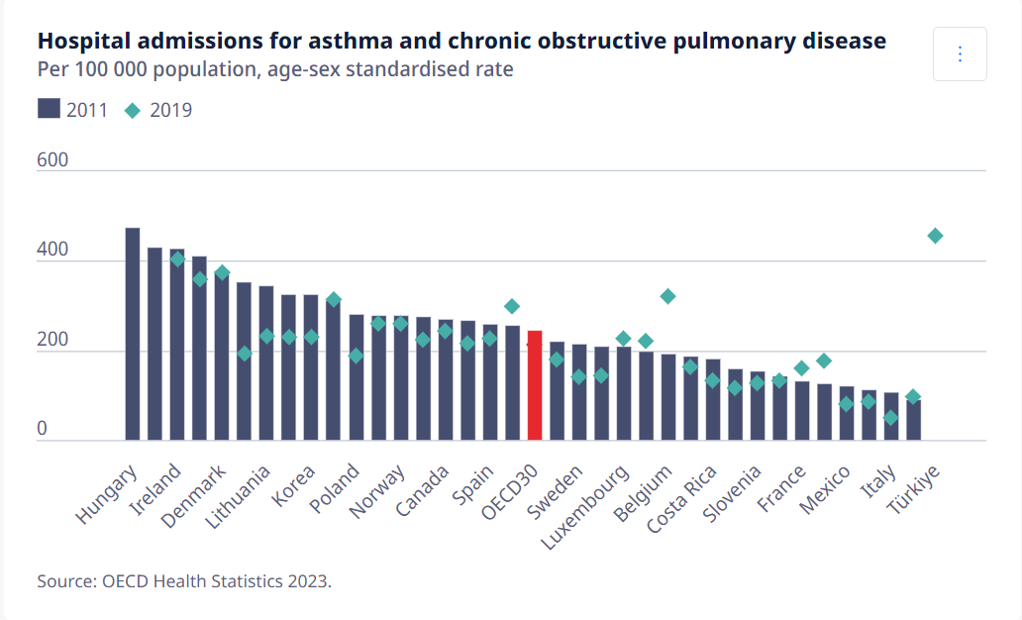  
**Introduction**

Medical care provides the initial point of contact for those who are finding medical assistance, making it an important part of healthcare systems. It is important for stopping the advancement of long-term illnesses. However, the present study analyses a hospital admission record for asthma and chronic obstructive pulmonary disease (COPD), emphasizing the role that inadequate primary care plays in enhancing hospitalization rates. The paper also points out problems with the chart's layout and offers suggestions for enhancing its display.

**Data Overview**  
The graph shows hospital admission rates per 100,000 persons in 30 OECD nations for both asthma and chronic obstructive pulmonary disease (COPD) between 2011 and 2019. It shows that how early management of chronic diseases through access to high-quality primary care might lower hospital admissions. The information shows an overall decrease in admissions between 2011 and 2019, showing advancements in medical care in most nations.

**Problem**  
The chart has several problems that make it difficult to understand well. In the beginning, viewers may become confused, and trends may be obscured by the visual confusion that results from representing data from 2011 and 2019 with both bars and diamonds. Due of the difficulty in telling the 2019 data from the 2011 data, this dual representation could be understood incorrectly. The viewer's ability to quickly determine nations and compare admission rates is further complicated by the small, crowded, and rotated x-axis labels. Overall, the clarity and usability of the chart is affected by these design decisions.

**The problem of lacking in Criteria**  
  
1. **Dual Data Representation**: When bars and diamonds are used together in the same area without a distinct division, confusion might occur. Viewers are not provided with an easy way to compare the data for the two years by the style of the graphic.

2. **Labelling Issues:** The accessibility of the nation labels along the x-axis has been severely affected by their small size and rotation, making them challenging to read.

3. **Colour Usage**: The colours are obvious, but by giving the bars for one of the years some texture or pattern, you may make them easier to see especially for people who are colour blind. This would help the process of identifying between the two sets of data.

**Solution**

**1.** **Separate Graphs for Different Years  
Solution:** To avoid combining bars and diamonds, make two distinct graphs or subplots for the years 2011 and 2019. This would make it possible to compare the data across time more clearly.

**2.** **Improved Colour Scheme and Visual Distinction**  
**Solution:** Make sure that others with difficulties seeing or colour blindness are able to identify the data points by using more distinct colours and signs for each year. This will make them find the information more easily.

**3. Clearer Labelling  
Solution:** To make one of the data sets easier to identify, expand the x-axis labels and make them horizontal or staggered. Additionally, increasing the font size's readability would make the chart easier to use.

**Conclusion**

The graphic offers useful details about how primary care lowers hospital admissions for long-term conditions like COPD and asthma. The chart might be turned more readable and educational by breaking out the years into separate graphs, enhancing the labelling and colour schemes, and making the similarities clearer to see. With these enhancements, primary care services in every nation might be improved and more data-driven decisions could be made by lawmakers and healthcare professionals.

**Reference***Healthcare quality and outcomes. (n.d.). OECD.* [*https://www.oecd.org/en/topics/health-care-quality-and-outcomes.html*](https://www.oecd.org/en/topics/health-care-quality-and-outcomes.html)

**Future health spending**

**Introduction**When it comes to showing important patterns and projections to support well-informed decision-making, data visualizations are important. Globally, there is growing stress over rising costs for health care. The average health spending as a percentage of GDP for each of the member nations up to 2040 is shown in an OECD graphic. Despite offering important insights into future healthcare expenses, this chart fails to meet to certain display standards, which could cause confusion. Therefore, I will be explaining some solution that can help to fix the chart diagram.   
  
**Data Overview**The average health spending in each of the OECD's member nations is shown in this graph as a percentage of GDP between 2018 and 2040. It presents two scenarios: the Maximum Efficiency Scenario, in which spending could be limited to 9.5% of GDP that wasteful expenses are reduced, and digital technologies are effectively utilized, and the Baseline Scenario and the Investment for Resilience, in which health spending is predicted to rise to 11.8% of GDP by 2040. The graph emphasizes how public health systems are under increasing pressure and how important it is to modify strategies to control future medical costs.

**Problem**The main problem with this graph is that its presentation might be confusing and unclear. The Y-axis starts at 8% rather than 0, which increases the physical difference between the two cases and gives a sense that the increase in health spending is more important than it is. Furthermore, the graph's lack of numerical labels for significant years like 2020, 2030, and 2040 forces users to make conclusions about the values, which lowers the accuracy of the information shown. It is challenging to separate between the two scenarios due to the overlap of the lines that reflect them. Finally, viewers end up without crucial context for completely understanding the forecasts because the graphic does not provide a clear description of the concepts behind each scenario.

**The problem of lacking in Criteria  
1. Y-axis Does Not Start at 0:**The Y-axis in the chart starts at 8% rather than 0%. This leads to a distortion that increases the visual mismatch between the two scenarios and gives the impression that the increase in healthcare spending is much greater than truly is. The Y-axis should begin at 0 for the most effective visualization to correctly represent the data.

**2. Key Points Have No Numerical Labels:**The graph displays the rising trends in healthcare spending, although important years (2020, 2030, and 2040) are not given numerical labels. This decreases the accuracy of the chart and causes the viewer to calculate the percentages.  
  
**3. Problem with the use of chart:**  
The line chart does not provide accurate and clear year-by-year data points, making it difficult to extract precise information. However, by using column chart will help to make the chart like more clearly than before.

**Solution  
1. Start the Y-axis at 0:**  
Set the Y-axis' initial value to 0%. As a result, the trends will be visually represented with greater accuracy and less deception, avoiding overstated gaps between the two scenarios.

**2. Add Numeric Labels:**  
Put numerical labels on both lines at strategic intervals. This will provide accurate information to viewers as well as quick understanding of the data.  
  
**3. Changing the chart:**By changing the line chart to column chart, which make the chart information more clearly to be seen and to make sure that the percentage value for each year. Not only that, using two separate sets of columns to show that the projections of health spending over the years.

**Conclusion**

The graphic does a good job of illustrating projected healthcare spending estimates for OECD nations, but it is deficient in a few important areas. Its accuracy and clarity are reduced by the Y-axis beginning above 0, overlapping data series, missing numerical labels, and poor explanation context. The chart can be made more accurate and inclusive for demonstrating significant patterns in healthcare spending by resolving several problems, such as beginning the Y-axis at zero, adding labels, better separating data series, and enhancing accessibility.

**Reference**  
*Health spending and financial sustainability*. (n.d.-c). OECD. https://www.oecd.org/en/topics/policy-issues/health-spending-and-financial-sustainability.html

**Obesity and being overweight**

**Introduction**  
Being overweight or obese is a risk factor for many non-communicable diseases, including diabetes, heart disease, and several types of cancer. As such, obesity and overweight are becoming global public health concerns. Due to changes in lifestyle and an increase in sedentary behaviour, the prevalence of these illnesses has been on the rise, especially in industrialized countries. Important information about the amount of overweight or obese adults in different nations is provided by the Organization for Economic Co-operation and Development (OECD), which is a valuable resource for understanding the scope of the issue in various geographical areas.

**Data Overview**The number of adults who are overweight or obese in various OECD nations is displayed in the chart headed "Self-reported overweight and obesity rates among adults." Adults who are overweight but not obese are represented by the green bars, while those who are obese are represented by the dark blue bars. The graphic shows the various rates of overweight and obesity in the various countries, with the United States dominating in both categories. The most recent year that is available is used to extract the data, in this example, 2021 or the closest year.

**Problem**

The high and increasing number of obesity and overweight people in developed countries is the problem at issue. This previous issue puts significant pressure on public health systems, resulting in a rise in non-communicable diseases (NCDs), decreased worker productivity, and rising healthcare expenses. Healthy food and exercise can frequently avoid these disorders, although the rise in these conditions has been attributed to changing lifestyle habits, such as increasingly unproductive jobs and harmful diets.

**The problem of lacking in Criteria  
1. Lack of Detailed Breakdown**

The graphic classifies people into overweight and obese groups, but it doesn't break down the various contributing variables like eating patterns, degree of physical activity, or economic status. Gaining an understanding of these variables might help explain why certain countries have greater rates.

**2. No Time Trend**

There is no information on whether these patterns have gotten worse or better over time because the chart only shows data for a single year. Including a time series could make it easier to determine whether strategies are working or whether the issue is becoming worse.

**3. Lack of a Social or Local Context**

There is no information on regional or cultural factors that could influence these rates in the data. Such as food customs or health promotion activities in various nations might vary, which affects the level of obesity. This background information would offer a more comprehensive understanding of the data.

**4.** **Lack of Explanation Impacts on Health**

The graph displays the number of obesity and overweight, but it does not discuss the possible negative effects on health, such as the number of diseases that are related to these problems. Such details might bring attention to how urgent the issue is.

**Solution  
1.** **Provide a Time Series:**To visualize changes over time, data from earlier periods might be used. This may demonstrate if obesity-related projects are having an impact or whether things are becoming worse. **2. Identify Important Elements:**

It would be easier to understand why some nations had greater rates of obesity if information on average diets, levels of physical exercise, or socioeconomic variables were included. This would increase the chart's accuracy.

**3. Provide Relevant Details:**

The chart could be more effective and accurately display the full cost of the rising rates if it included data on the public health results of obesity and overweight, such as the frequency of diabetes or heart disease in each nation.

**4.** **Better Labelling and clarifications:**

Providing notes or clarifications which bring attention to the most important findings such as the gender gap or high rates in particular nations should be included on the chart. These would make the chart more readable for a wider audience and assist in guiding the reader through the data.

**Conclusion**  
The OECD countries obesity and overweight rates chart is an useful chart that brings attention to the growing public health concern of rising obesity rates. It does a good job of presenting the essential facts, but it lacks important information that would allow us to fully understand the problem, including temporal patterns and contributing causes. Improving the graphic with extra background information, factors to explain, and past data could make it a more complete representation that can guide public health attempts to fight obesity. To address this issue and enhance population health outcomes by lowering the risk of private illnesses, national policy initiatives as well as individual behaviour changes are needed.

**References**  
  
*Improving public health*. (n.d.-b). OECD. https://www.oecd.org/en/topics/improving-public-health.html